Part D Accumulator claims - Automation - Read Me |  |  |  | 
Department | Part D Accumulator - Claims |  | Date of Report |  | 05/22/2024
Automation | Group Creation , Search, Update and View - Automation
Jenkins URL | https://arg-qualctl-jenkins.ssnc-corp.cloud/view/DailyView/job/DomaniRx_ADJ_Regression_Accumulators/
Data Path & Template | (Template Name) - Full Path (TBD)

Table of Contents
RxNova - Group - Automation - Read Me 1
JOB DESCRIPTION 1
COVERAGE 3
Test Cases: 3
TEST DATA 5
JENKINS JOB EXECUTION PROCESS 6
EXECUTION RESULTS 7
Latest Build stats 10
Defects/Open Issues 10
Immediate issues / Questions 11

Author | Kranthi Kumar Kondaveeti
Reviewers | Sreenu Babu Nallajaru
Draft | Version 1.1

JOB DESCRIPTION
Accumulator Part D claims - Submitting and validating claims for Basic Part D, Part Multi-Straddles, Low-Income Subsidy with codes 1, 2, 3 and 0 and Accumulator costshare overrides for Drug options (Brand Name, Generic Name, GCN Seq Number and MEDID), Drug Type options(MSB and SSB) and Days-Supply options(Greater than, Less than, Range, Exact Match) for Group Level accumulator option and Plan level accumulator options.

Job Access:
Jenkins CI/CD tool All tab DomaniRx_ADJ_Regression_Accumulators

https://arg-qualctl-jenkins.ssnc-corp.cloud/view/DailyView/job/DomaniRx_ADJ_Regression_Accumulators/

URL: Supported Executions:
Scheduled Builds & daily runs

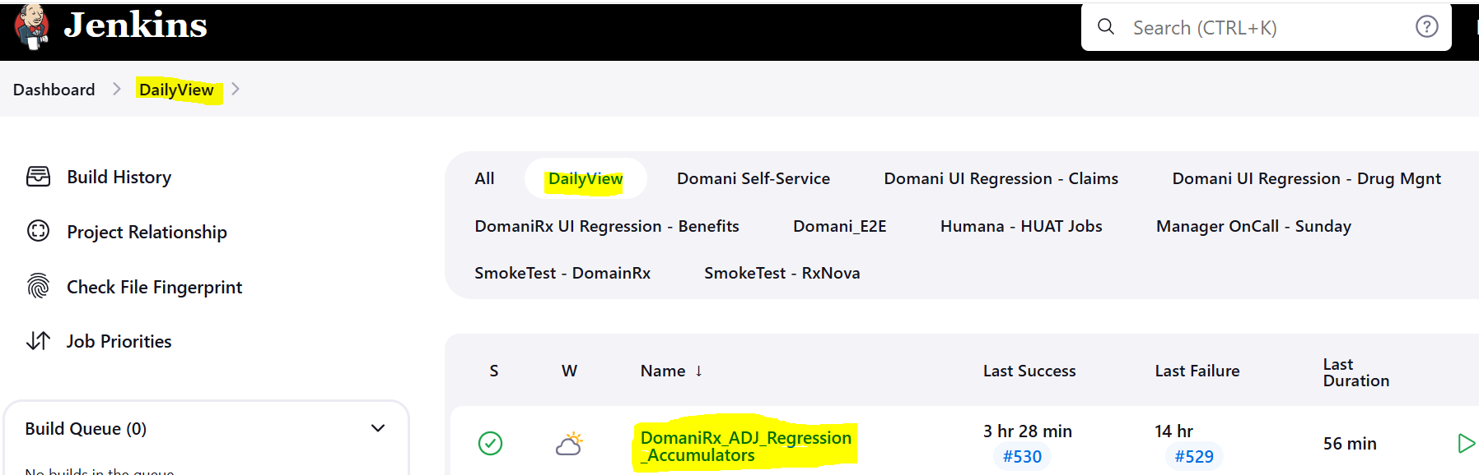

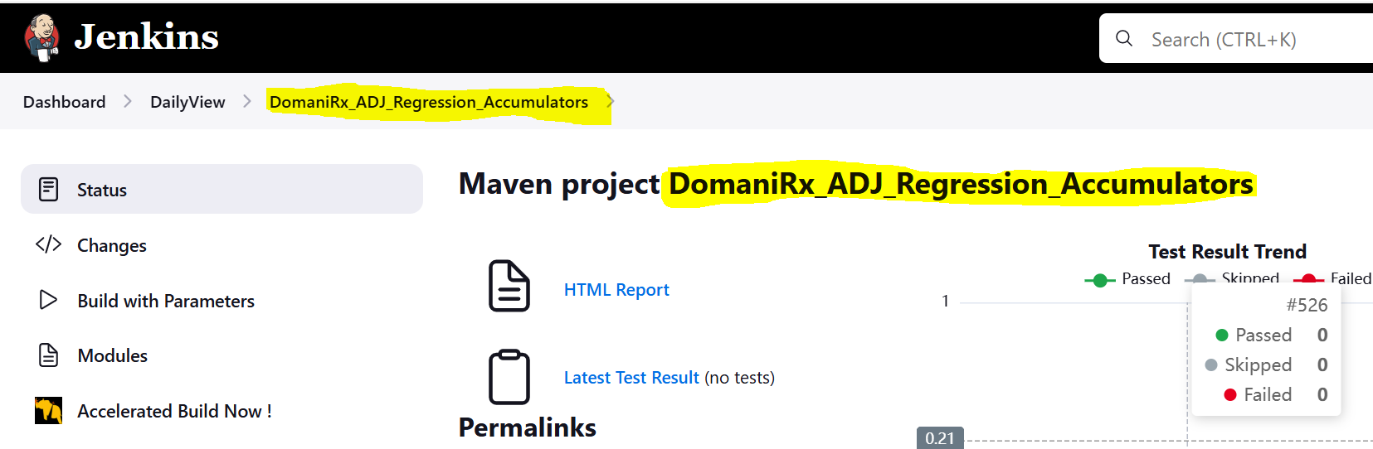

COVERAGE

Test Repository Location in Jira:
https://domanirx.atlassian.net/projects/PSAUT?selectedItem=com.atlassian.plugins.atlassian-connect-plugin:com.xpandit.plugins.xray__testing-board

Navigate to – E2E_Claims/Accumulator_PartD

Test Cases:
  - 34 Cucumber Type (Test Repository/ E2E_Claims/Accumulator_PartD/)
  - 770 Manual Type (Test Repository/ E2E_Claims/Accumulator_PartD/)

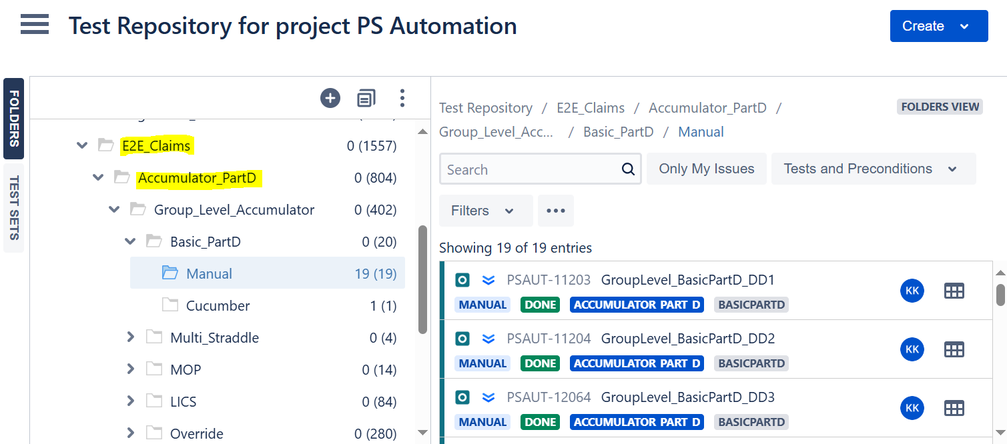

E2E claims for Accumulator PartD:

TEST DATA

Location:
https://code.ssnc.dev/pharmacy/PSRegressionAutomationSuite/blob/main/src/test/resources/DataSheets/Group/GroupDataTemplate_QC.xlsx

https://code.ssnc.dev/pharmacy/PSRegressionAutomationSuite/blob/main/src/test/resources/DataSheets/Group/GroupData.json

Group validation test data can be found on GitHub, under PSRegressionAutomationSuite project by clicking on link provided above, downloading file and opening Group sheet.
If for some reason user wants to update test data, updated excel file must be uploaded to GitHub and next Jenkins run will use that updated data. In such situations please reach out to Automation team under Sreenu Babu Nallajaru to help with file uploading and running it.
Please Note**
- Excel file consists of separate sheets in respective to each Group scenario that validations are done for.
- Sheets are mapped in a way that all fields are covered and is easy to follow based on headers provided.
- Each scenario is written in a way that is specifically targeting certain components/fields and modifying TC name, headers, fields targeted, would result in failures.
- External Group ID’s are auto generated while running script and uploaded back into excel, so no need to worry about group duplications and such.

Template location:
TODO
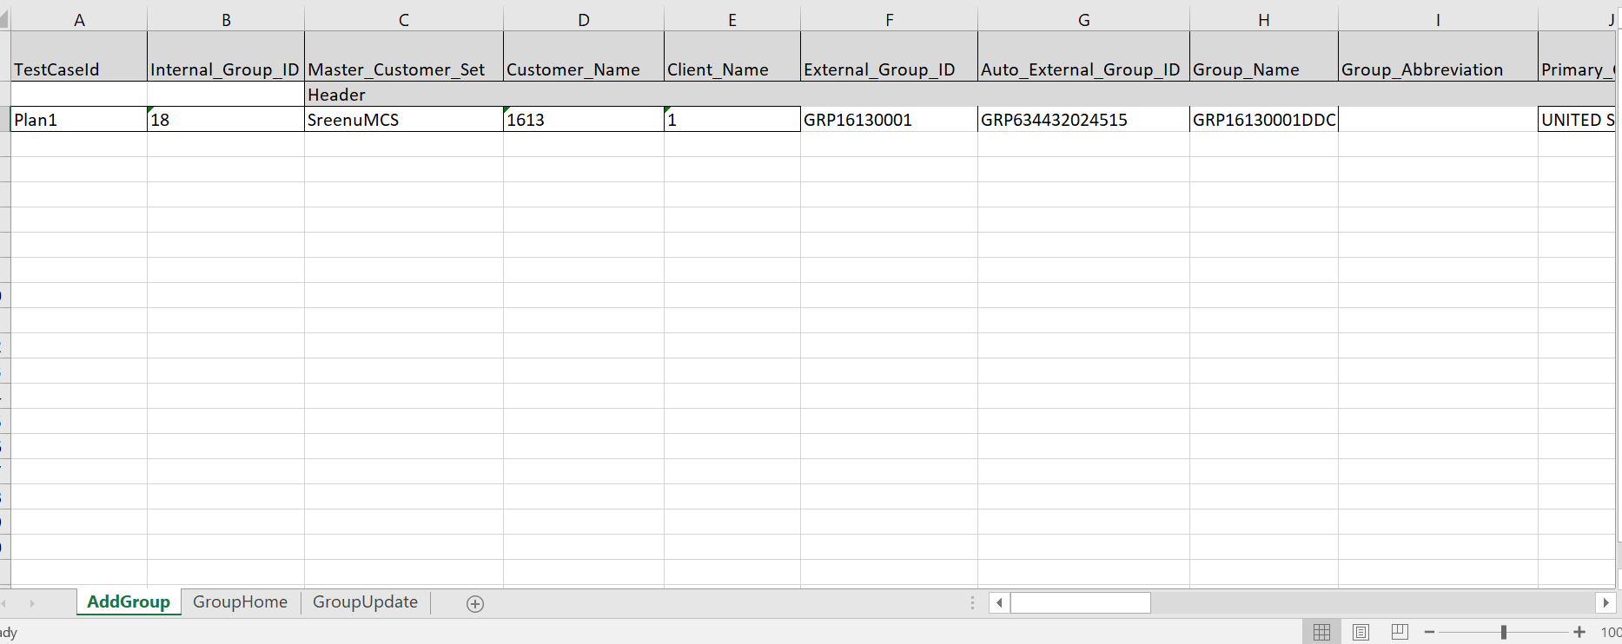

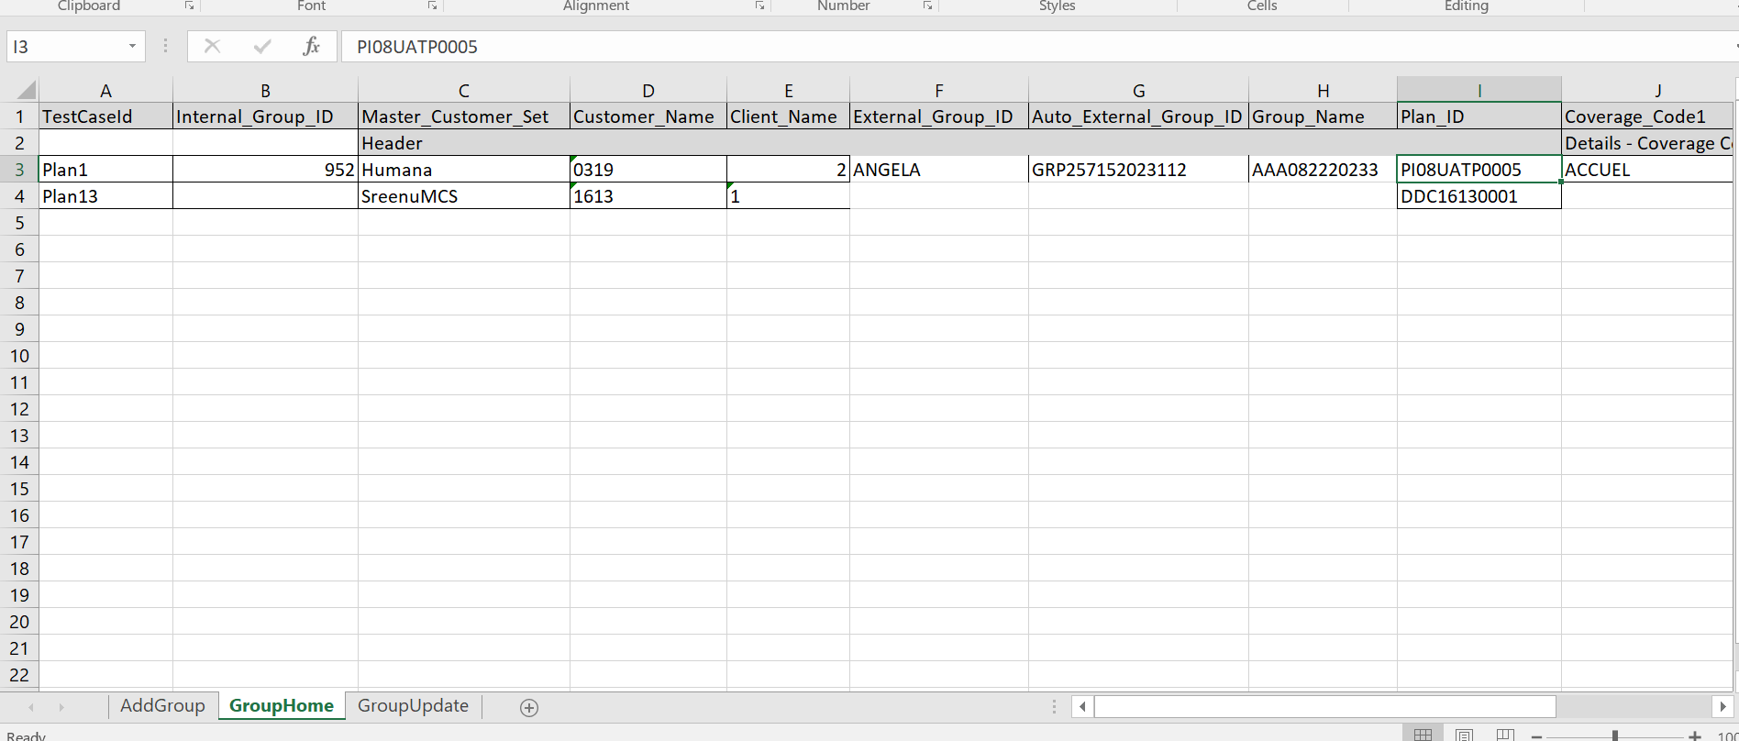
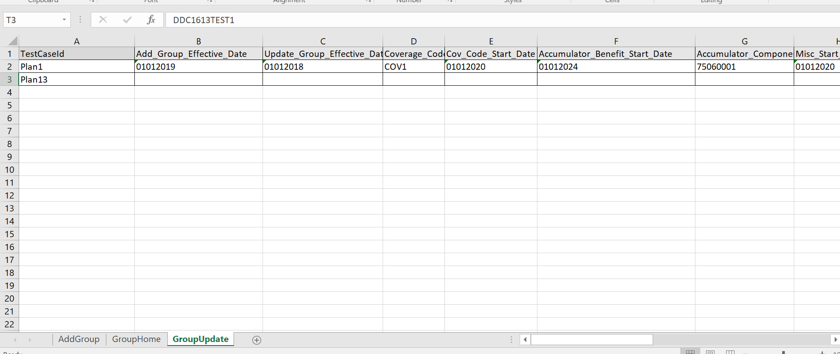

JENKINS JOB EXECUTION PROCESS

Steps:
- User navigates to Jenkins URL provided above (see screenshot 1)
- Click on “Build Now” (see screenshot 1)
- Build will appear in Build History section and will be marked as in progress
- At this time user can wait until the run is completed to see the HTML report
Execution Time: 1hr 25min 56 sec

EXECUTION RESULTS

Steps:
- Click on desired Build (it is very important to note down your build number once execution starts) (see screenshot 2)
- Click on HTML Report (see screenshot 3)
- Serenity HTML report will open with overall Test Results for this job (see screenshot 4)
- Browse through very detailed and well captured Test Results (see screenshot 5)
- Every test will have screenshots captured and steps recorded (see screenshot 6)

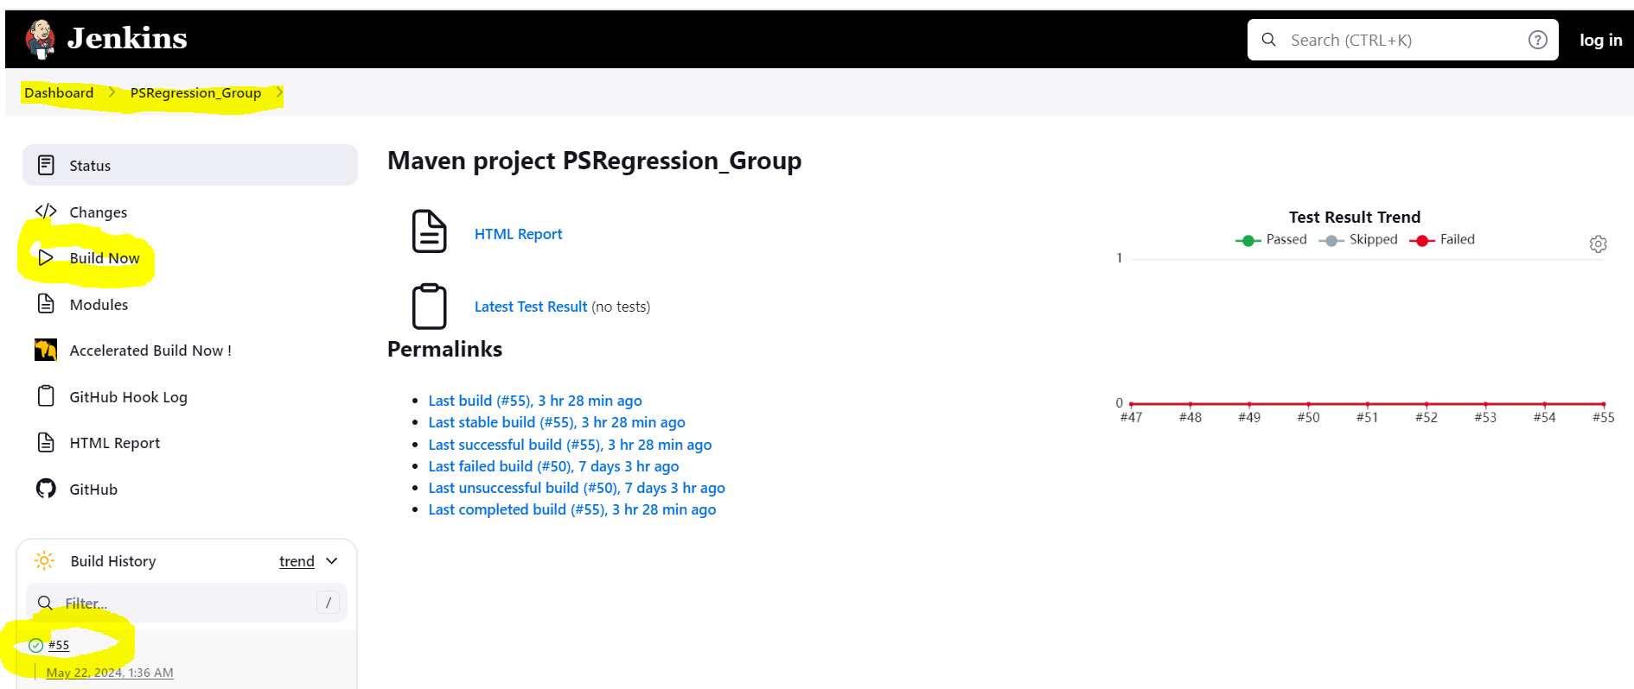
- Screenshot 1 -
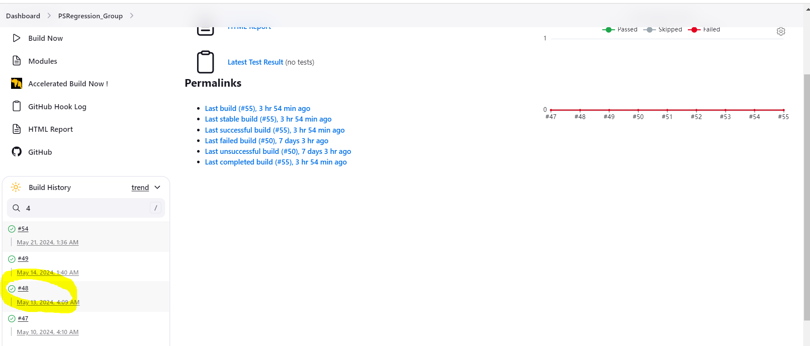
- Screenshot 2 -

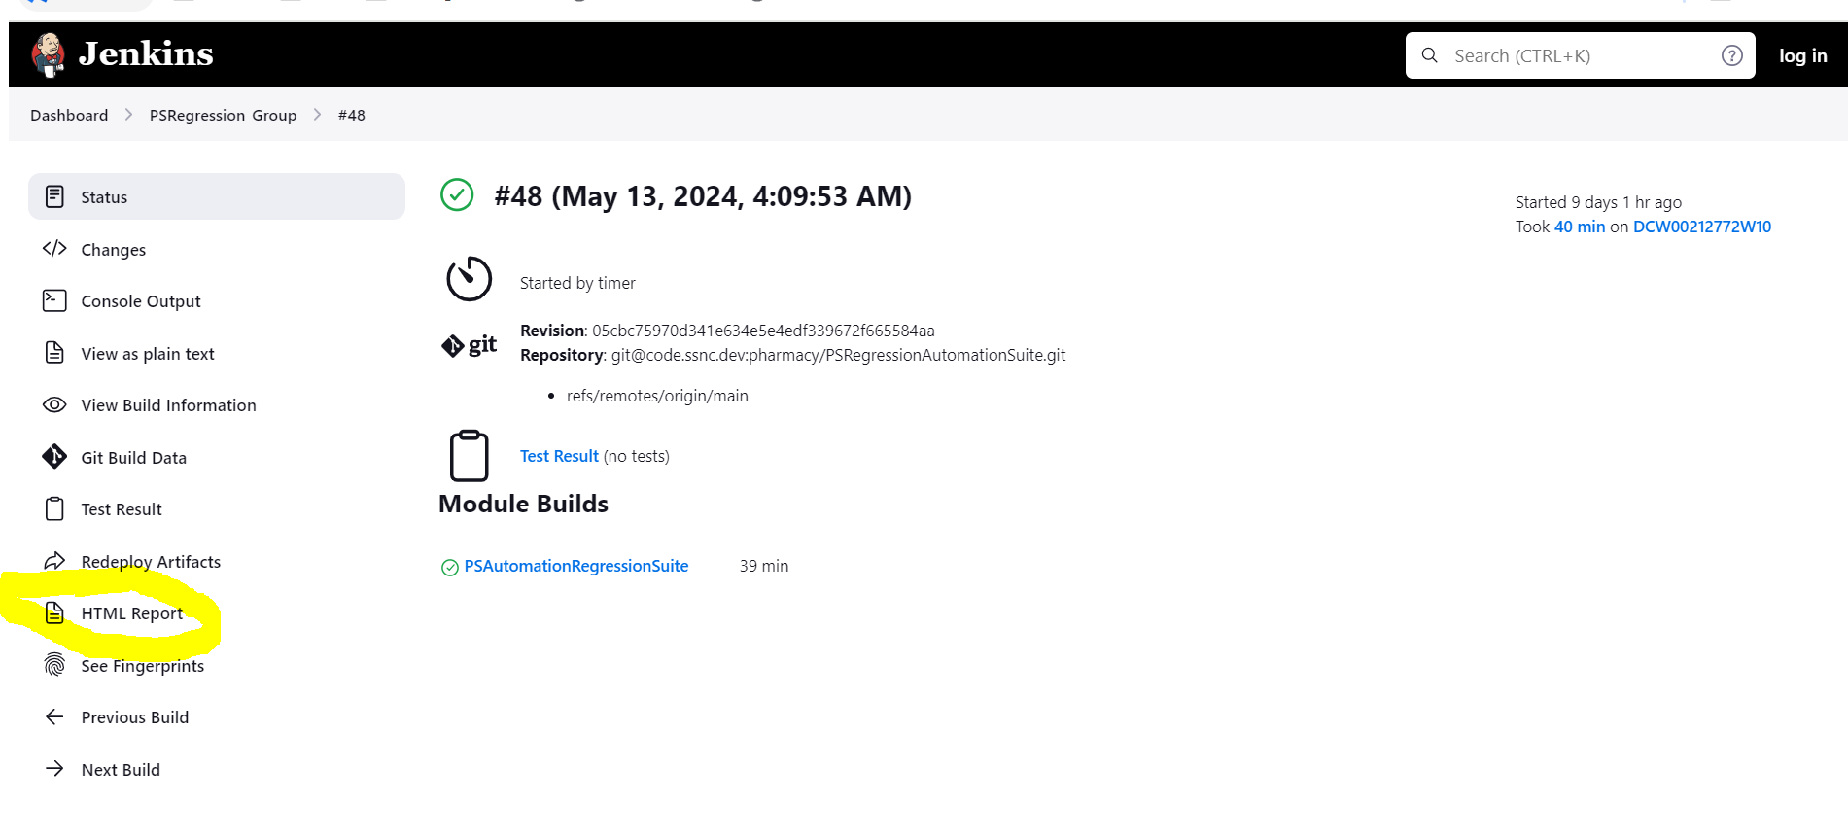- Screenshot 3 -

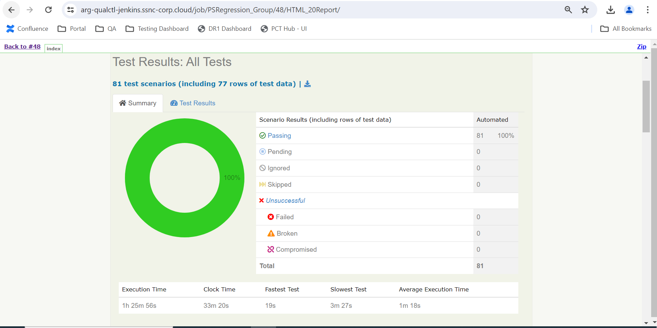- Screenshot 4 -
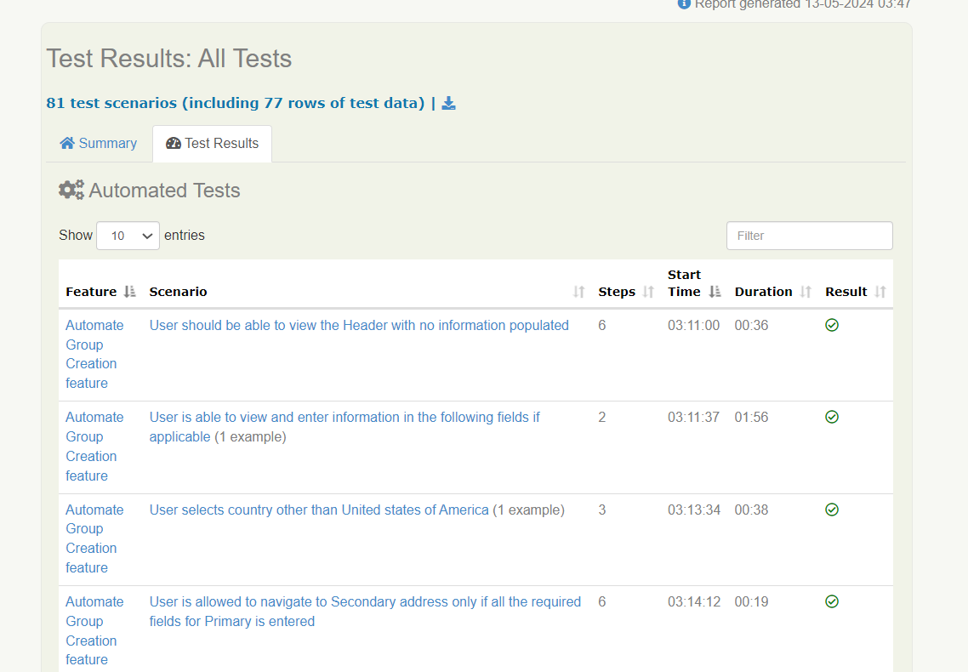
- Screenshot 5 -
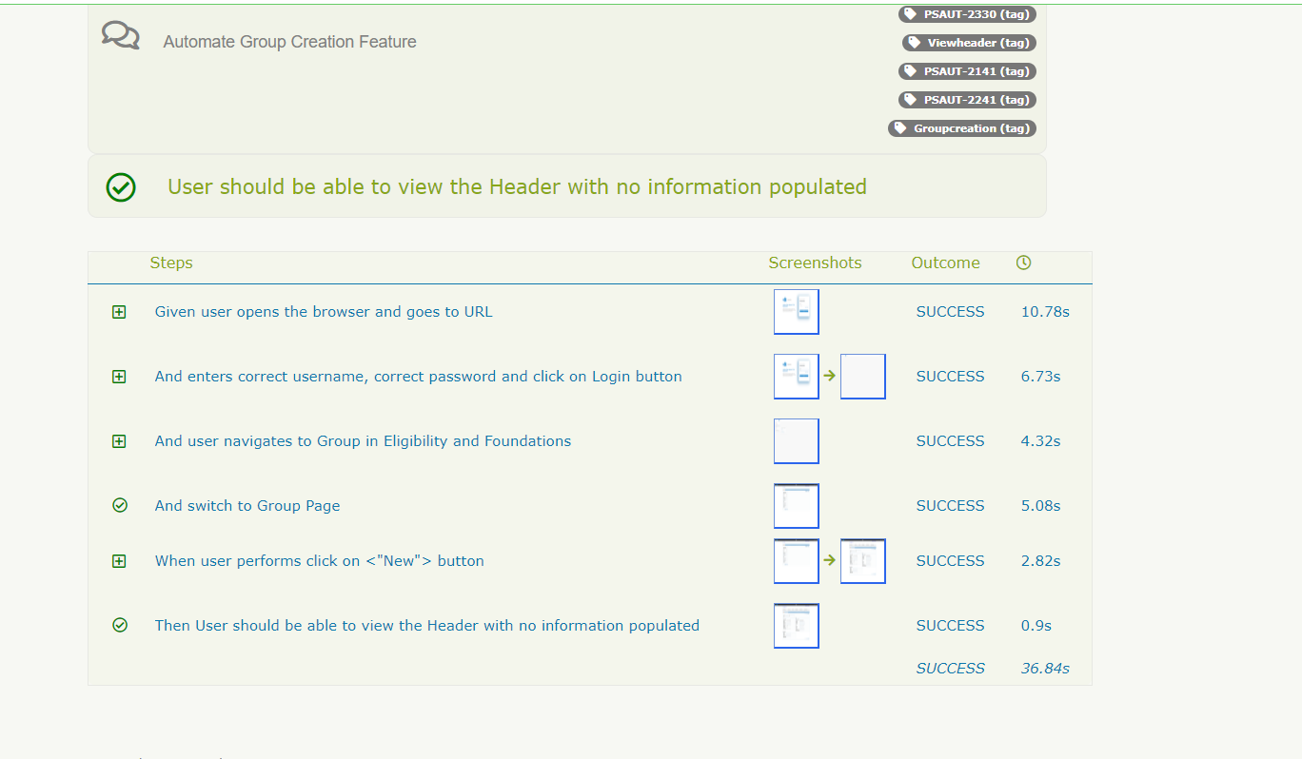
- Screenshot 6 –

Latest Build stats

Date of execution: 05/13/2024
Automation: Group
Execution time: 1hr 25min 56s
Passed: 100%

Open Issues/Questions:

- If we enter date in Group Start Date in "Group Effective Date" screen and then remove it, click on Add, then it will give error near Start Date and also at the top. Then again we will give correct date and click on Add (See Screenshot 7 below). → Error near Start Date is removed but error at top is still present.

Comments From Barry :- We have noticed this as existing behavior in some of the group screens. We are not updating the screens at this time to get rid of this error but it is something we are looking at updating in the future.
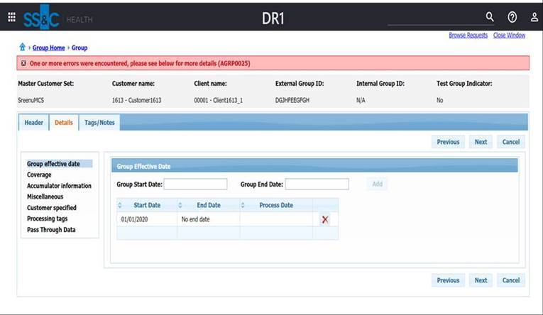
- Screenshot 7 –

Immediate issues / Questions
Please reach out to Latika Tilwani /Sreenu Babu Nallajaru for any question related to this Automation Item.

